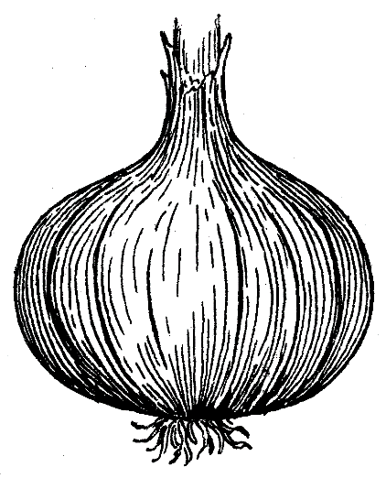
2024 COLUMBIA COUNTY 4-H
VIDALIA ONION FUNDRAISER

“You’ll Only Cry When They’re Gone”

ORDER DEADLINE: March 25th

WRITE IN & TOTAL YOUR ORDER BELOW
ONLY ORDERS WITH PAYMENTS WILL BE PROCESSED

OFFICE USE ONLY

Office Code: _________

Date: ______________

Payment Method:

Card Cash Check

Check # _____________
Item Name | # Items | Item Price | Item Total
4-H Vidalia Onion Cookbook |  | $5.00
5 lbs. Vidalia Onions |  | $6.00
10 lbs. Vidalia Onions |  | $12.00
25 lbs. Vidalia Onions |  | $22.00
40 lbs. Vidalia Onions |  | $32.00
 |  | Grand Total:

Form must be filled out completely including an e-mail! This is how we contact you for pick-up.

FULL NAME: CELL PHONE: ____________________

EMAIL:

PAYMENT & DELIVERY INFO
PAYMENT METHODS include Cash, Check, or Card*.
*Credit Card payments are only available in-person at the office.
Payments can’t be made over the phone or online & no cash through mail.

CHECKS PAYABLE TO: UGA Extension /Columbia County 4-H
BRING OR SEND TO: 6420 Pollards Pond Road, Appling, GA 30802
PHONE: 706-541-4011 ● FAX: 706-541-4012
You may fax your order & then mail in your payment separately.

TENTATIVE DELIVERY DATE
1st week of May - County Roads & Bridges - 2257 County Camp Rd, Appling, GA
An exact date will be communicated from our seller, and emailed out.
*All proceeds go to Columbia County 4-H to provide educational programs & scholarships in Camps, Health & Nutrition, Agriculture, Leadership, Citizenship, DPA & Professional Development

An Equal Opportunity, Affirmative Action, Veteran, Disability Institution: If you are an individual with a disability who may require assistance or accommodation in order to participate in or receive the benefit of a service, program, or activity of UGA, or if you desire more information, please contact us.

